Lesson 06 – Converting Problem Statements to Flowcharts
Problem Statements and Flowcharts
This is where we take our problem statements that we have worked on and turn them into a flowchart.
Once we take a problem statement and analyze it using structured problem-solving techniques, we can then convert the problem statement into a flowchart. This brings us one step further into creating an actual implementation. With a flowchart the solution can be communicated across multiple teams, and a general understanding of the solution is gained.

Conversion
The first thing we should do when we convert a problem statement into a flowchart is to identify the key actions and decisions that are needed to solve the problem. This includes inputs, outputs, conditionals, processes, and anything else that makes up part of the solution.
In previous lessons, we discussed how to analyze a problem statement. We identified key components in a problem statement and organized them based on the requirement.
Consider the following problem statement:

“A local bookstore wants to implement a loyalty program to reward their frequent customers. They plan to offer a 5% discount on every purchase for customers who have spent more than $500 in total at the store. Write a program that will calculate the total discount a customer is eligible for based on their total spending and output the total discount to the user.”
The key actions and decisions in the problem statement are underlined, but let’s list them out as well.
- Inputs: User purchase amount.
- Process: Calculate total discount (5%)
- Output: Total discount.
- Conditions: Purchase total must be greater than $500.
With the key components identified, we can begin to create our flowchart. It is useful to follow a structured approach when converting a problem statement to a flowchart.
These are the steps to follow:
- Identify the starting and end points (the terminal and terminators)
- Break the process into clear, sequential steps
- Assign appropriate flowchart symbols
- Ensure logical flow and completeness
Let’s take the problem statement and design a flowchart based on it, using this structured approach.

Identify the start and end points
Based on the problem statement, our starting point would be when the user enters the customer’s purchase amount. We would place our Start symbol before this step.
The end point is after the total discount has been output to the user, so our End symbol would go after this step.

Break the process into clear, sequential steps
Breaking up the process into sequential steps is similar to how it was done during the structured problem-solving lessons. We want to have one step per symbol in our flowchart.
Let’s create the steps:
- Start program
- Enter purchase amount
- Check if the purchase amount is greater than $500
- If it is, then calculate the discount
- Print the discount (assume the discount will be 0 if amount is less than 500)
- End program
Assign appropriate flowchart symbols
Once we have the steps laid out, we need to assign the correct flowchart symbol based on the operation being performed in that step. For the example above:
- Start program – (Type: Terminal; Shape: Oval)
- Enter purchase amount – (Type: Input; Shape: Parallelogram)
- Check if the purchase amount is greater than $500 – (Type: Decision Point; Shape: Diamond)
- If it is, then calculate the discount – (Type: Process; Shape: Rectangle)
- Print the discount - (Type: Output; Shape: Parallelogram)
- End program - (Type: Terminator; Shape: Oval)

Ensure logical flow and completeness
We have the steps, and the shapes required for our flowchart. Now we can build it. As we design it, we must make sure that the logical flow (using arrows) is correct and that we don’t miss any elements in our design.
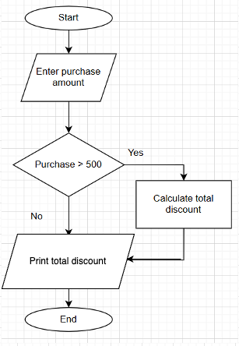

Refinement
As problems become more complex, solutions and their flowcharts will become more complex alongside them. With increased complexity comes increased risk for error, over-design, or need for areas of improvement.
Refinement is the process of going back to our original designs and improving them. It is very important to refine our flowcharts once we have completed them. One of the primary reasons for refinement is to remove any logical errors and improve the clarity of our design.
Depending on the complexity, there could be mistakes in our designs. It could be necessary to refine a flowchart multiple times, or have others review your flowchart for problems.
The reason for refinement is to ensure that the solution is 100% clear to anyone looking at. People from across an organization should be able to look at the flowchart and identify what is supposed to happen, where, and in which order.
Some areas that can be noted for refinement include:
- Correct shapes are used
- Logical consistency
- Readability
- Verifying Decision Points
- Efficiency
- Removing unnecessary steps
Correct shapes
It may seem inconsequential but using the correct shapes when designing flowcharts helps adhere to industry standards. When people from other, less technical teams look at a flowchart, they are looking for specific shapes to represent specific parts of an algorithm or process. During refinement, double check that the correct shapes are used.
Logical consistency
A major part of designing a flowchart is not only identifying which steps need to be taken, but also in which order they need to be taken. All process steps / symbols need to be connected logically so that the flowchart accurately describes the process we are trying to represent. If it not logical, it is not done correctly.
Readability
Since flowcharts are meant to simplify processes by making them easier to understand, they also need to be readable. A flowchart that has an unbroken chain of 30 steps is not going to be easy to follow and people will get lost while reading it. It is better to break up a large flowchart into smaller, logical pieces using connectors. Refinement is a great time to do this.
Verifying Decision Points
Decision points are critical pieces of algorithms in software development. When doing refinement, we need to make sure that each decision point has two output paths so that our algorithm behaves as expected. This can sometimes be addressed at the same time as addressing Logical Consistency.
Efficiency and removing unnecessary steps
Efficiency is a key aspect of good algorithm development. We can write algorithms that work, but they may be slow or have a bunch of unnecessary steps (which often slows down a program). Being able to identify and remove unnecessary steps is required when designing algorithms, and refinement is a very good place to do that.
When we design algorithms, one of the first goals should be to “make it work.” During refinement, we can update our solution to “make it work efficiently.”

Refinement Example
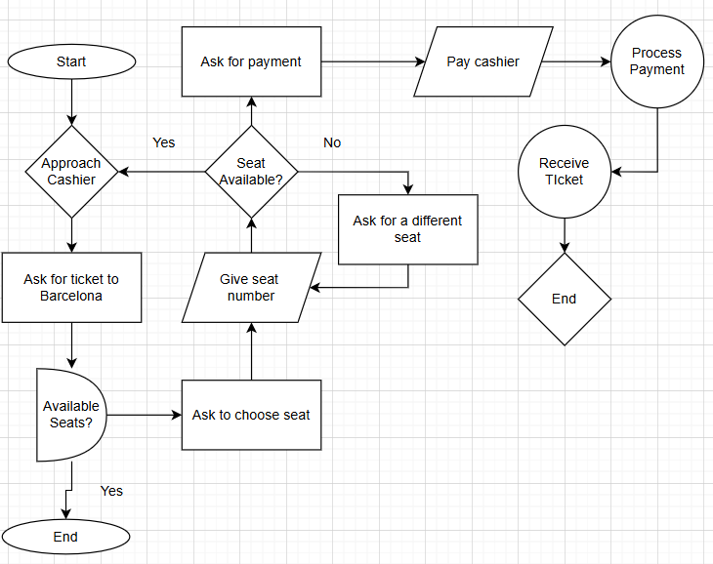
Okay. What is going on?
Confusing right? This is supposed to be a flowchart about purchasing a plane ticket to Barcelona but looking at it there are too many errors to be able to know exactly what is going on. Let’s look at the areas to fix again.
- Are the correct symbols used? No.
- Is it logically consistent? No.
- Is it readable? No.
- Are the Decision Points correct? No.
- Is it efficient? Unsure.
- Can we remove unnecessary steps? Unsure.
There are a lot of things to fix, and until they are fixed, we cannot know if the flowchart is efficient.
Let’s fix the errors one section at a time.
Symbols
The following symbols are incorrect:
- Approach Cashier. It is a process, so it should be a rectangle, not a diamond.
- Request Ticket to Barcelona. It is an input (choosing a location to travel), so it should be a parallelogram, not a rectangle
- Available Seats. It is a decision point, so it should be a diamond, not a semi-circle.
- Process Payment. It is a process, so it should be a rectangle, not a circle.
- Receive Ticket. It is an output, so it should be a parallelogram, not a circle.
- End. The second End symbol should be an oval, not a diamond.
Here is the fixed version (fixes in blue):
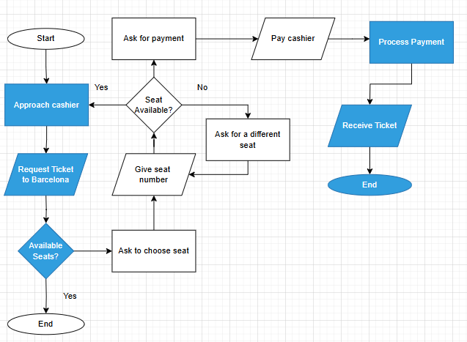

Logical Consistency and Decision Points
There are a few logical errors here:
- Available Seats. The “Yes” label is on the wrong arrow. If there are available seats, we should proceed to the seat choosing section.
- Seat available? Here is a serious logical error. The “Yes” arrow restarts the ticket buying process into a never-ending loop. This arrow should be removed. The “Yes” label should be moved to the arrow on the top since we want to proceed to the payment section if the seat is available.
New version (fixes in blue):
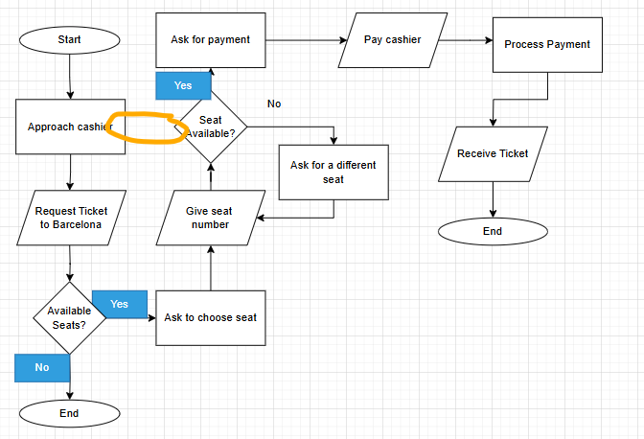
Readability
This flowchart is not very readable for the following reasons:
- Too long. This flowchart is so long that it can be easy to lose track of where we are in the process. Connectors should be used to make it more readable.
- The logical flow travels upwards at points. Flowcharts are meant to be read Top-Down / Left-Right. The upward travel of arrows is incorrect.

Fix (added connectors and made flow top-down / left-right):
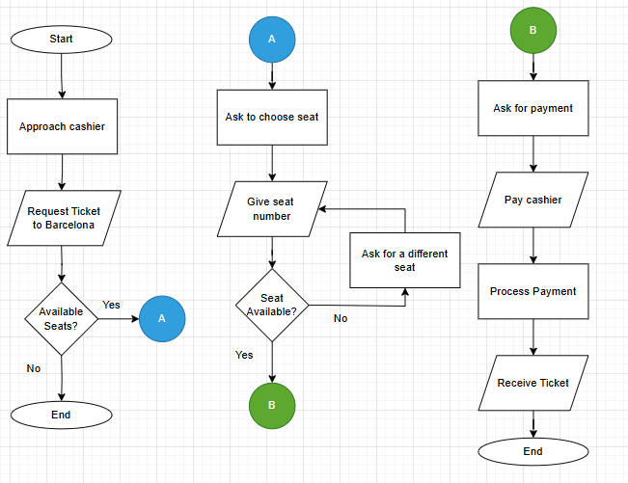

Efficiency and removal of unnecessary steps
Now that the errors have been corrected, we can take a larger view of the flowchart and see if there are other areas to improve. We could not analyze a flowchart with so many errors.
As far as efficiency is concerned, the updated version is pretty good. One improvement that could be made to the algorithm is asking the passenger if they want another flight if there are no available seats, but that is okay.
There aren’t any repeated steps, unless you include the two “End” symbols. In this case, we would leave them separate. Even though both End symbols are on the same page, because of the connectors they are part of their own “chunks” and should be treated independently.

Refinement Summary
When refining a flowchart, as in all problem-solving, it is much easier to fix small things one at a time rather than trying to fix everything at once.
The original flowchart had a lot going on, but when we tackled one issue at a time, it made it more manageable.

